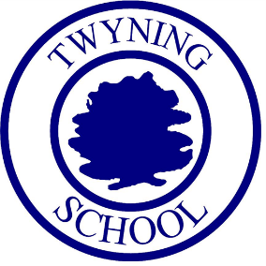 | Twyning School
Music Curriculum Intent

What is the experience of learning Music at Twyning?
At Twyning our children are musicians who develop a love of all aspects of music through:

- Singing and performing key songs as individuals and in groups
- Listening to and talking about music from across the world
- Whole school singing and seasonal productions.
- Learning about a range of composers (from different ages, cultures and genres) in lessons and through extra curricular clubs and ACE days
- Composition opportunities using their voice, school instruments and other resources
- Recording composition ideas on shared and individual staves
- Learning instruments in class ensembles
- Improvising with percussion, instruments and voice
- Performing to their peers, parents and visitors at the end of topics
- Learning to recognise and read treble clef

What are the core concepts we want the children to know?
- Knowledge of music theory focusing on dynamics, genres, key signatures and time signatures
- Singing songs safely and with control
- Using voice expression including dynamic and mood choices
- Listening to and appraising a range of pieces
- Controlling pulse and rhythm
- Exploring sounds - melody and accompaniment
- Control and care when playing instruments
- Composition of new ideas
- Reading and writing formal and informal notation
- Performing with flare and confidence
- Evaluating and appraising works of themselves and others
- Knowledge of composers and musicians throughout time and how they have affected the music we hear and love today

What does it mean to get better at Music?
Pupils show musicality, enjoyment and confidence when expressing themselves through music. This can be evidenced by:

- Pupils will show improved knowledge of music theory and musicians from different points in time.
- The children’s improved accuracy in performances, both vocally and instrumentally
- Pupils taking on performing opportunities for a range of audiences, growing in confidence when participating
- Pupils enjoying, sharing and being proud of their own performances and compositions
- Children appraising music with growing understanding, using musical vocabulary confidently and respectfully
- Pupils to show an improved understanding of musical notation and how to play music accurately

How have we chosen what to teach?
- We base our sequence of teaching on the progression of learning which is set out in the national curriculum.
- We use the Charanga Model Music curriculum alongside Gloucestershire Music hub tuition.
- We have a range of instruments in school for class use, both freely and through set teaching structures (xylophone/chime bar lessons and whole class instrumental lessons)

Learning through Achieve, Create, Enjoy.
- They are able to nurture their musical interests through practical and engaging activities in school and excel in their musical achievements.
- Pupils use music for self expression and to share a message.
- Pupils experience an enjoyment of music though many exciting performance opportunities and experiences.

